Silvan SIRUS installation guide

Step 1: Open the Box. Contents of box are as follows
- Sirus
- USB Extension Cable
- Power Supply
- IR Blaster
Step 2: Connect Power Supply to nearby power source. Extend the cables, if needed.
Step 3: If required, connect a USB extension cable from Power Supply to Sirus. - Optional
Step 4: Paste the devices on top side or any other suitable side of the air conditioner indoor unit using the double-sided tape in the packaging.
Step 5: Connect the IR Blaster to Sirus 3.5 MM jack and paste the Blaster (as shown in pictures below) at the air conditioner IR receiver. This completes the installation of Sirus.

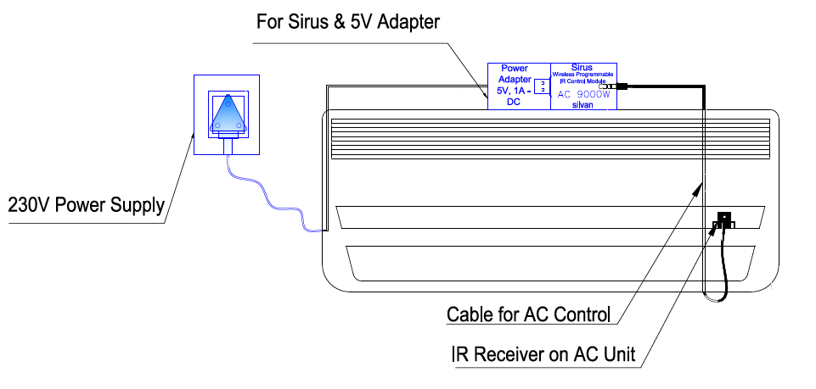
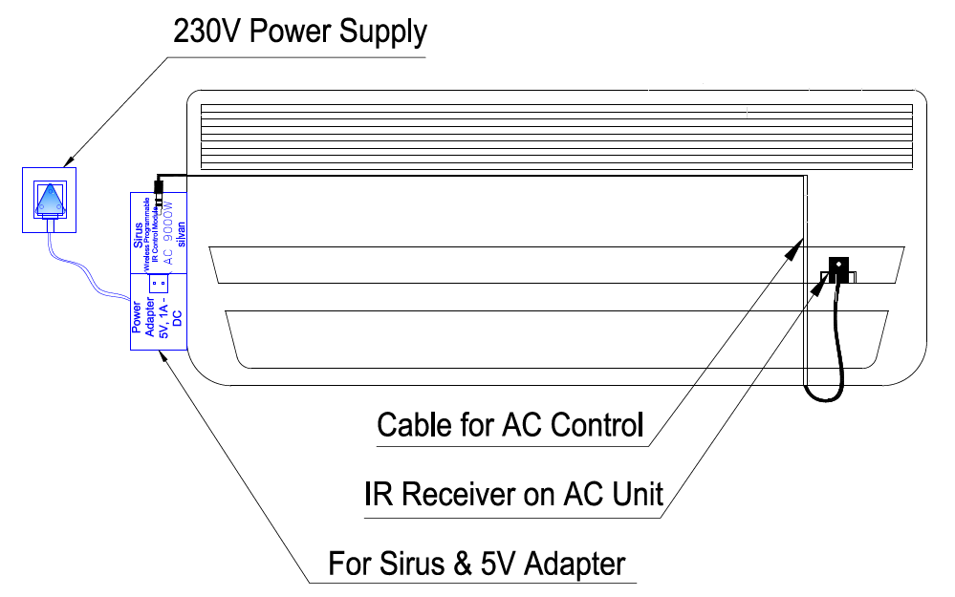
Mounting Option 2
Mounting Option 1

Silvan
Smart Spaces Simplified
www.silvan.co.in

For any support related query, please contact:
e-mail: support@silvanlabs.com
Contact: +91 91080 01821-22

